 

**Placement Empowerment Program**

***Cloud Computing and DevOps Centre***

60 Days of DevOps Challenge

***Day 8: Docker Basics***

***Name: Mary Edlyn A Department: CSE***



**Challenge 1**: Write a simple Dockerfile that runs a Python script using an official base image (python:3.9)

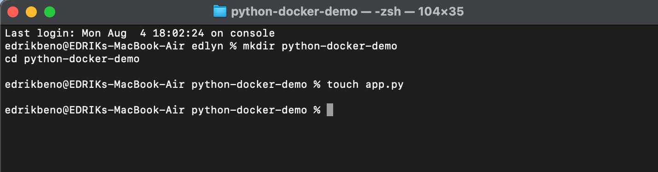

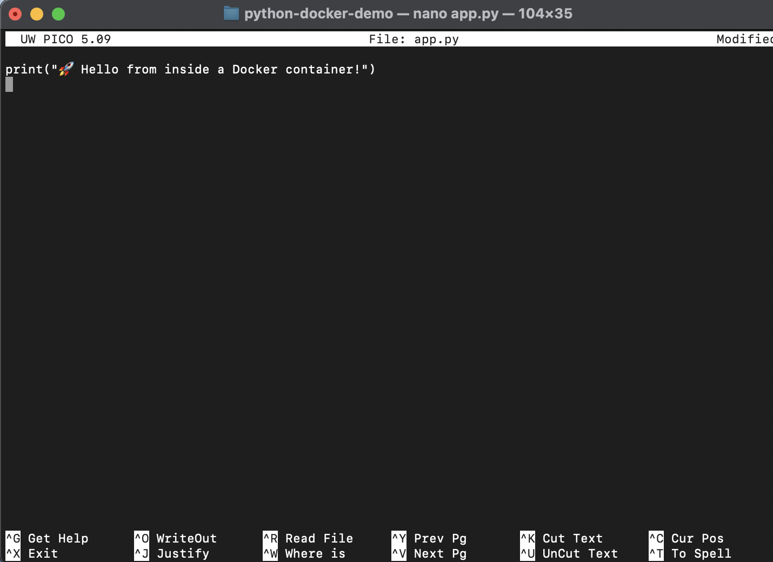

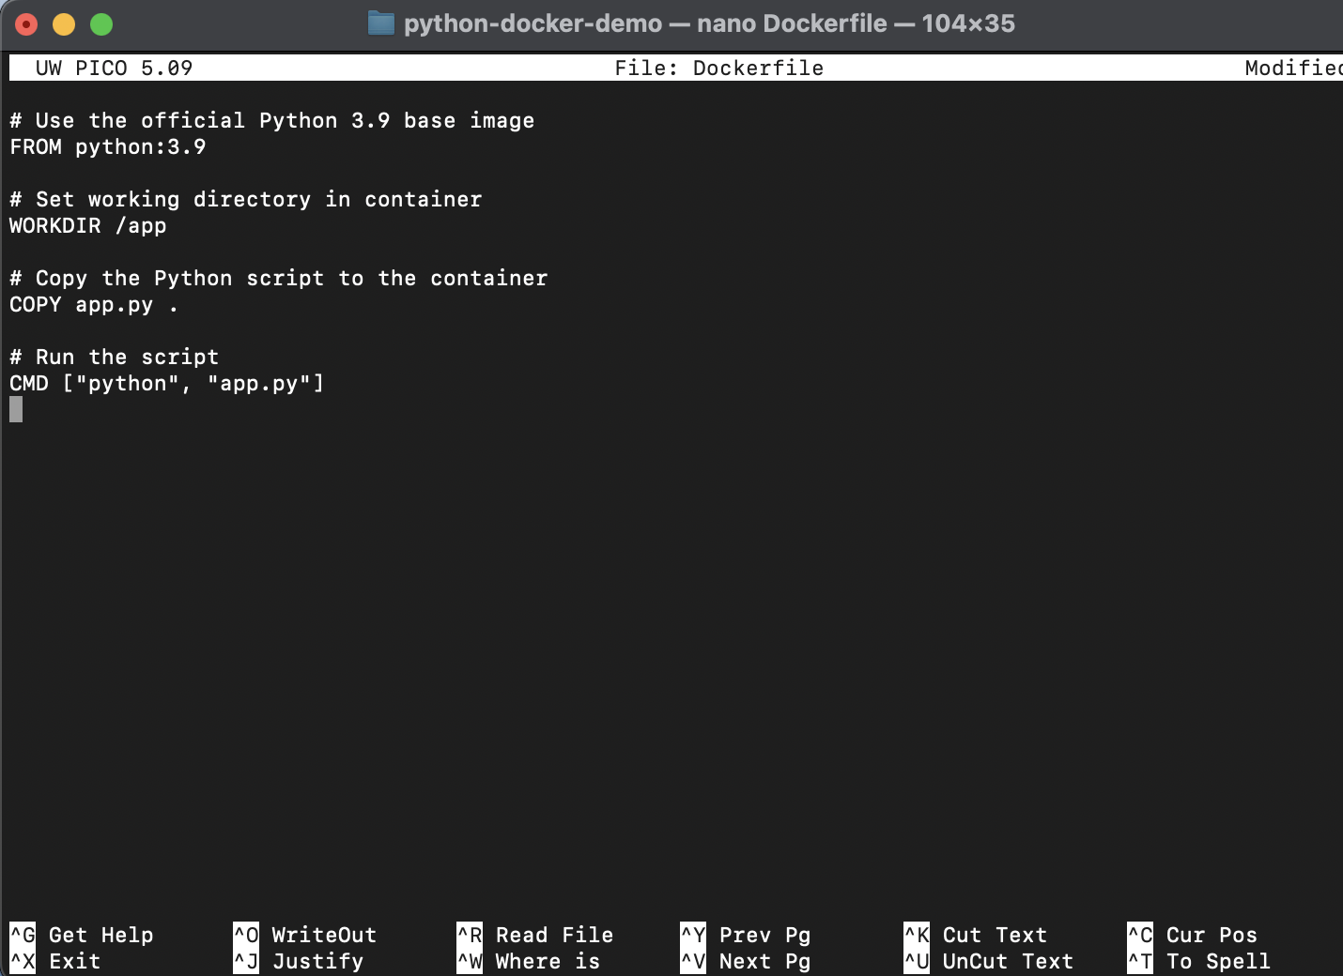

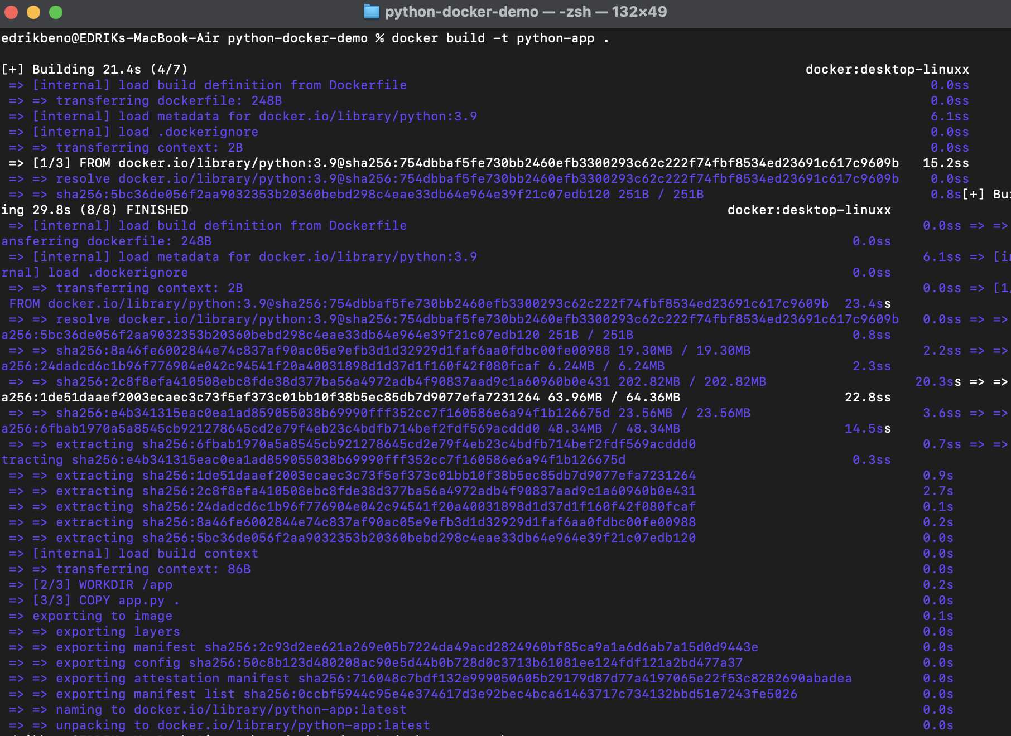



### **Challenge 2**:  Build a Docker image from your Dockerfile and tag it with a version (docker build -t myapp:v1 .)





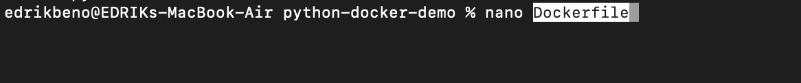 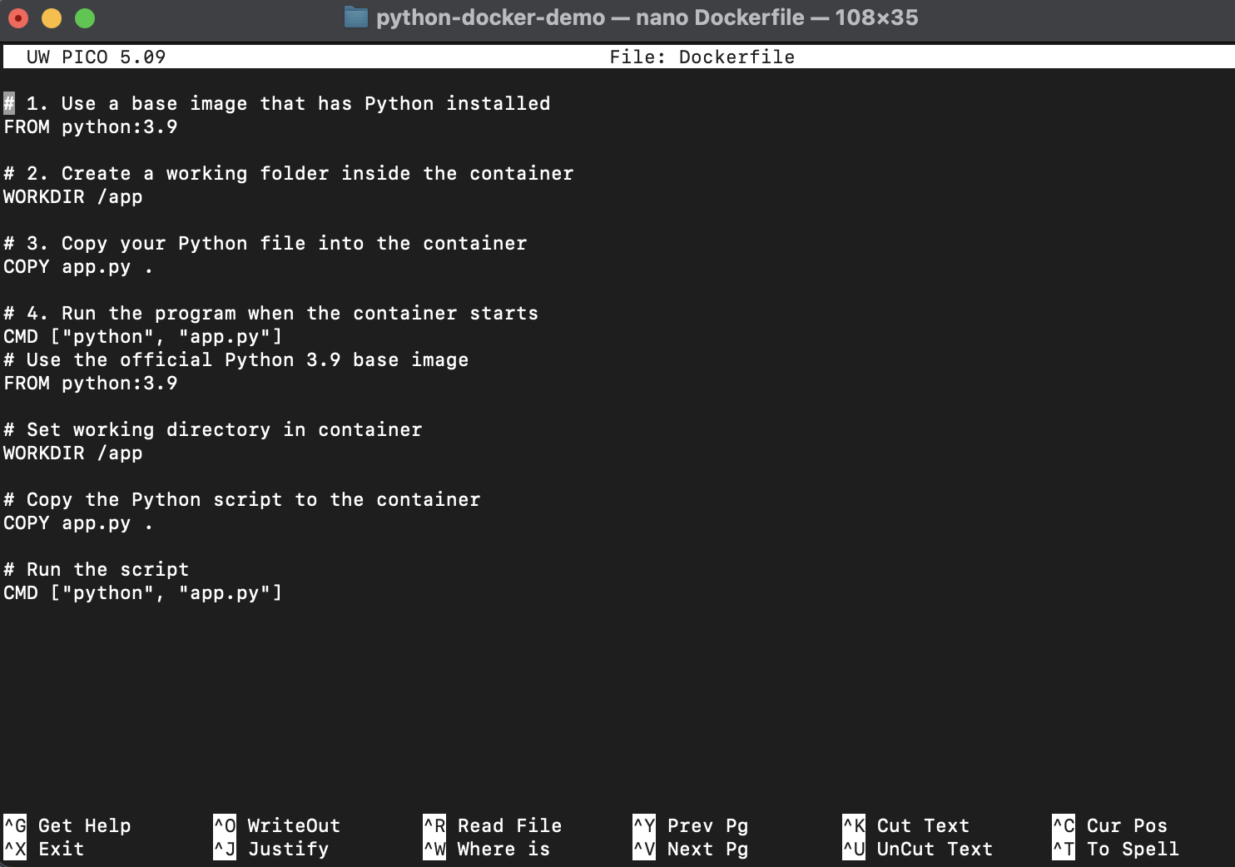

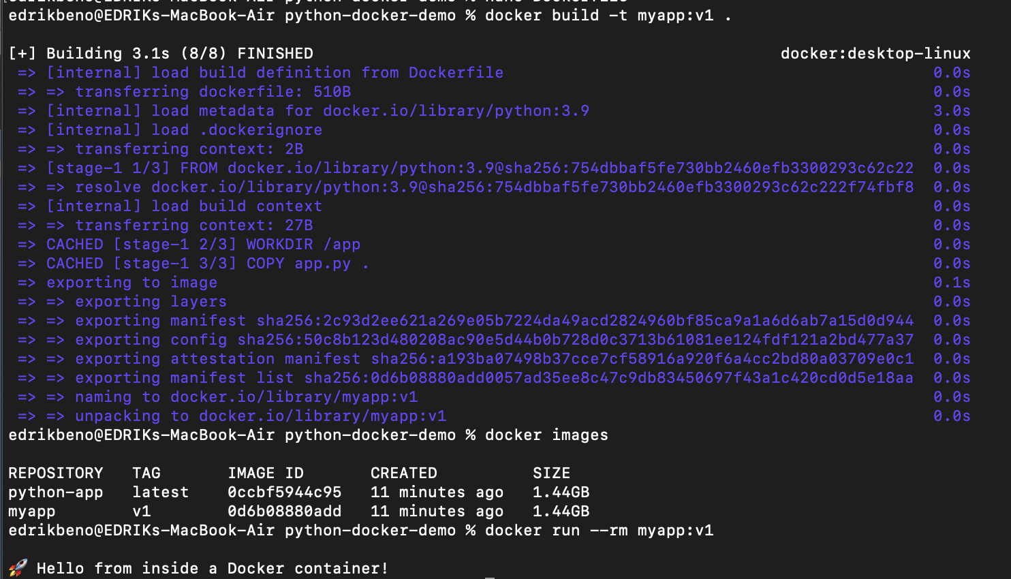

### Challenge 3: Run a detached container (-d flag), restart it, and check logs (docker logs <container_id>)

